MTM-Labor 4

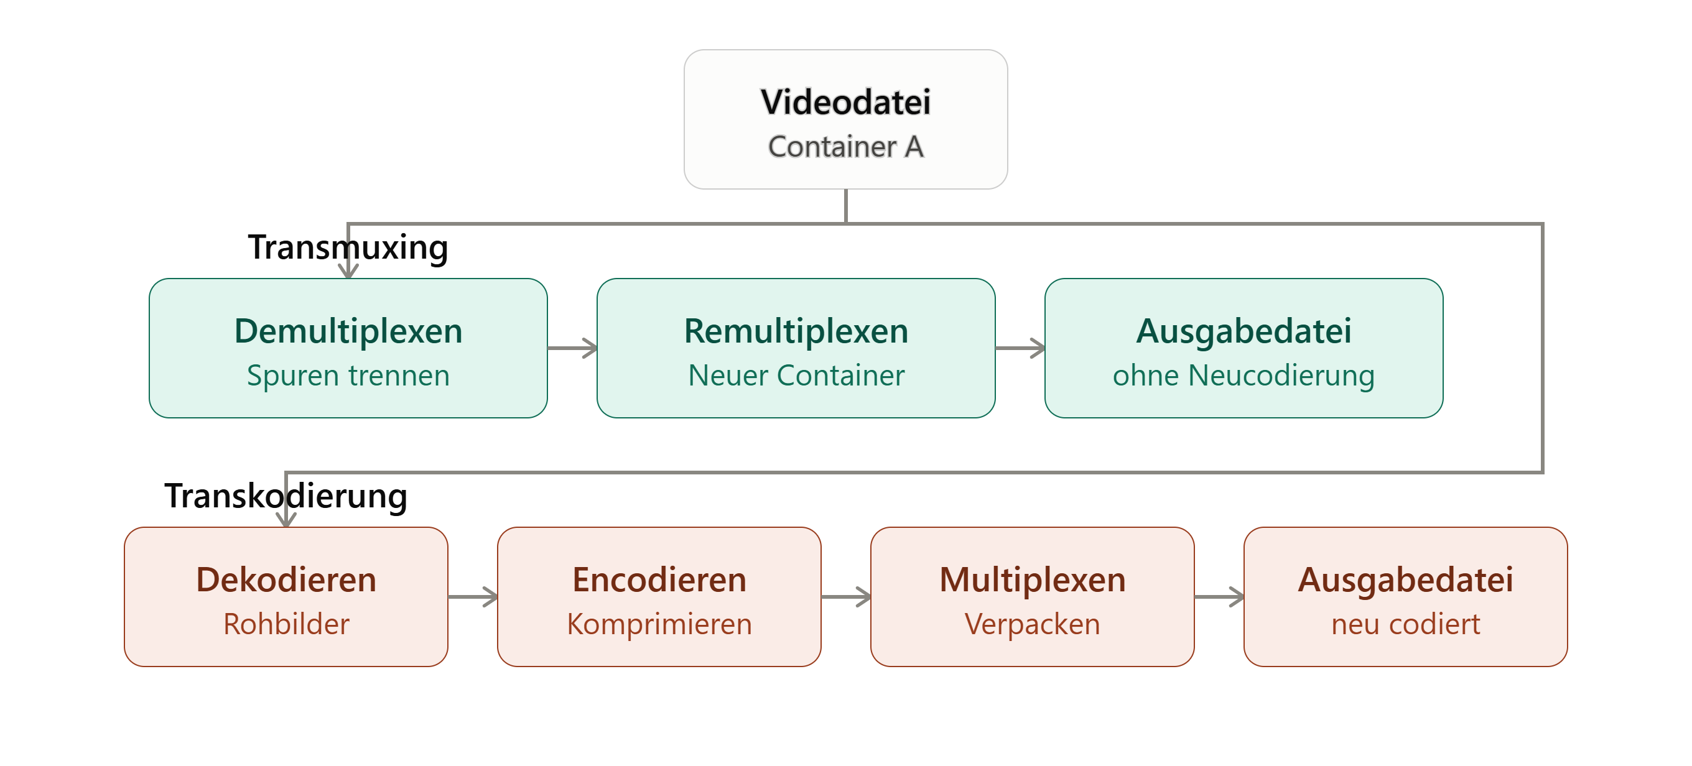

01

a)

ffmpeg -i foreman_1000.264 -c copy foreman_1000.mp4
FFmpeg verlustfrei (Stream Copy, ohne Neukodierung) in einen MP4-Container gemuxt.
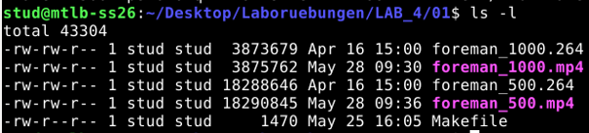
Container-Overhead durch das Muxen in MP4 (moov-/moof-Atom, Sample-Tabellen, ftypHeader etc.)
Differenz (500): 2.199 B
Differenz (1000): 2.083 B

b)
x264 --bitrate 500 --bframes 0 --output foreman500_b0.264 foreman.yuv --input-res 352x288
und 10 B Frames
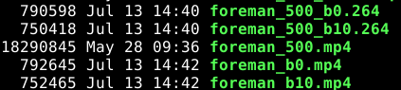
Bei .264:
- foreman_500_b0.264: 790.598 Bytes
- foreman_500_b10.264: 750.418 Bytes
- Differenz: 40.180 Bytes
Bei .mp4:
- foreman_b0.mp4: 792.645 Bytes
- foreman_b10.mp4: 752.465 Bytes
- Differenz: 40.180 Bytes

- Overhead bei b0: 792.645 Bytes (.mp4) - 790.598 Bytes (.264) = 2.047 Bytes
- Overhead bei b10: 752.465 Bytes (.mp4) - 750.418 Bytes (.264) = 2.047 Bytes
Kein Unterschied

c)
Mit ffprobe foreman.mp4 Duration ermitteln: 11.9 Sekunden

ffmpeg -i foreman_500.264 -i Jahzzar_-_01_-_Out_of_School.mp3 -c:v copy -c:a copy (-shortest) foreman_500_audio.mp4

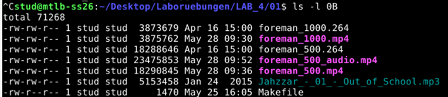

23475853-18288646-5153458=33749
Der Overhead für Video + Audio beträgt nun 33.749 Bytes

02

a)

MP4Box -diso foreman_500_audio.mp4
Mp4, Videospurspezifische Box
Diese Box deklariert die Art der Medienkomponente. Das Kürzel vide steht unmissverständlich für Video. Sie sagt dem Player, dass alle nachfolgenden Medien-Informationen in diesem Pfad als Videodaten interpretiert werden müssen.
20 Bytes groß., „vmhd", Formatversion 0, Flag 1 Standard (Rendering beachten)
Audiospurspezifische Box
HandlerBox
hdlrType="soun" und Name="SoundHandler"
soun steht für Sound (Audio). Diese Box deklariert, dass der gesamte folgende Pfad Medien-Informationen für die Audiospur enthält.
16 Bytes groß., „smhd": Typ-Code, Formatversion 0, Flag 0: keine Steuerungs-Flags set
File Type Box
Type=„ftyp":
Size=32Bytes groß
MajorBrand =“isom“: MPEG-4-Part-12-kompatibel
Container="file otyp": Zeigt an, dass diese Box direkt auf der obersten Ebene der Datei (File-Ebene) liegt.

b)
MP4Box -diso foreman_500_audio.mp4 -info
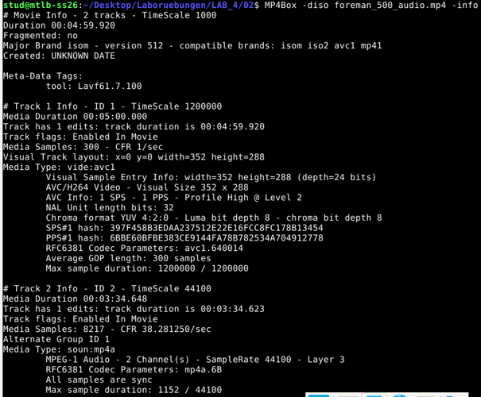
menschenlesbare Zusammenfassung (Auflösung, Framerate, Codec-Parameter, Sample-Statistik).

03

a)
ffmpeg -i AmosTV_10min_HT.divx -c copy AmosTV.mp4
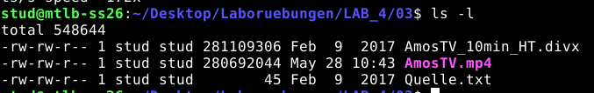
Dateigröße im DivX-Container: 281 109 306 Byte
Dateigröße im MP4-Container: 280 692 044 Byte
Differenz: 417.262Byte ist DivX größer, deshalb sieht es so aus, als ist mp4 besser. Medien Daten durch copy ident. Unterschied lediglich Overhead.
Das MP4-Format organisiert Metadaten, Indizes und Paket-Header effizienter als der ältere AVI-basierte DivX-Container.

b)
ffmpeg -i AmosTV.mp4 -an -c:v copy AmosTV_mp4.m4v -vn -c:a copy AmosTV_mp4.mp3
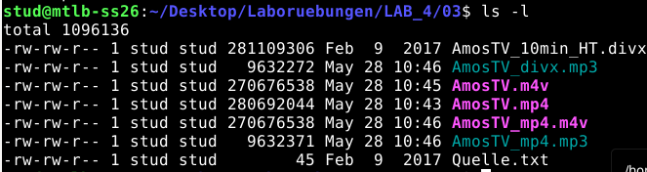
Video+Audio= 280.308.810Byte
Divx: 281.109.306
MP4: 280.692.044

Overhead divx: 800 496
Overhead mp4: 383 135
Weniger als halb so groß.

c)
mkv Container:
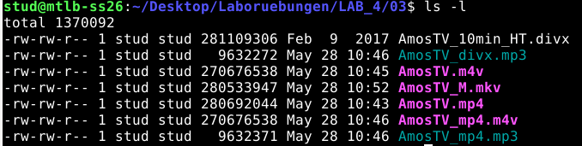

MP4>MKV, um 158 097
Overhead: 225 038

Code
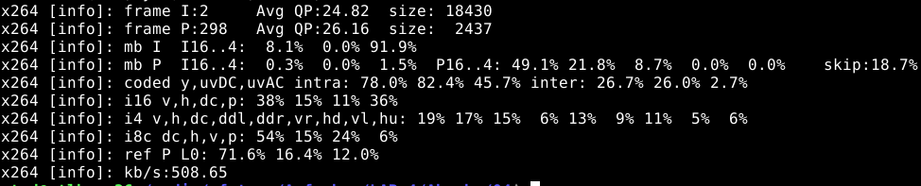

av_write_trailer(fmt_ctx) den abschließenden Teil der MP4-Struktur – insbesondere das moov-Atom mit den vollständigen Sample-Tabellen (Zeitstempel, Byte-Offsets, Keyframe-Positionen etc.),

X264 header: https://code.videolan.org/videolan/x264/-/blob/master/x264.h?ref_type=heads

Function Name | Purpose | Parameters
x264_param_default_preset | Initializes an x264_param_t structure with default settings based on a speed preset and a performance tuning profile. | • x264_param_t *param: Pointer to the parameter structure to populate.  • const char *preset: Speed preset string (e.g., "medium").  • const char *tune: Tuning option string (passed as NULL).
x264_param_apply_profile | Restricts and modifies configuration parameters to strictly comply with a standardized H.264 profile specification. | • x264_param_t *param: Pointer to the active parameter structure.  • const char *profile: H.264 profile level string (set to "baseline").
x264_picture_alloc | Allocates internal memory buffers for a picture structure based on a specified width, height, and color space format. | • x264_picture_t *pic: Pointer to the picture structure to allocate.  • int i_csp: Integer color space macro (e.g., X264_CSP_I420).  • int i_width: Frame width in pixels.  • int i_height: Frame height in pixels.
x264_encoder_open | Instantiates and opens a new master encoder engine using the finalized configuration parameters. | • x264_param_t *param: Pointer to the configuration structure containing settings.
x264_encoder_encode | The core encoding engine. Converts raw uncompressed frame data into compressed H.264 Network Abstraction Layer (NAL) packets. | • x264_t *encoder: Pointer to the active master encoder instance.  • x264_nal_t **nal: Address of an unallocated NAL pointer; filled automatically with compressed data payloads.  • int *pi_nal: Pointer to an integer that receives the generated NAL unit count.  • x264_picture_t *pic_in: Pointer to raw input picture data (or NULL to flush).  • x264_picture_t *pic_out: Pointer to a structure that receives the metadata of the frame currently being outputted.
x264_encoder_delayed_frames | Queries the encoder's internal lookahead and B-frame buffers to check if delayed frames are still waiting to be flushed out. | • x264_t *encoder: Pointer to the active master encoder instance.
x264_picture_clean | Frees internal memory buffers allocated inside an x264_picture_t structure by a prior allocation call. | • x264_picture_t *pic: Pointer to the allocated picture structure to clean up.
x264_encoder_close | Gracefully shuts down the encoder engine, freeing all internal threads, lookahead queues, and library scratchpads. | • x264_t *encoder: Pointer to the active master encoder instance to destroy.

b)
FFmpeg / MP4 Muxing Functions & Parameters
Function Name | Technical Purpose | Parameter Explanations
av_packet_alloc | Dynamically creates and initializes an empty AVPacket instance structure on the heap. | Returns: A pointer to an empty allocated packet, or NULL if allocation fails.
avformat_alloc_output_context2 | Allocates an AVFormatContext for an output media container format based on file extension names. | • AVFormatContext **ctx: Destination pointer to save the newly created context.  • const AVOutputFormat *oformat: Forced format selector struct (passed as NULL).  • const char *format_name: String name of the container target specification (set to "mp4").  • const char *filename: String output file path string used to guess missing properties.
avformat_new_stream | Spawns a new logical data track channel stream (audio or video) inside an active format container. | • AVFormatContext *s: The parent container format context managing the destination target.  • const AVCodec *c: A specific structural codec selector reference pointer (passed as NULL).
avio_open | Safely opens the file system target file resource for reading or writing data byte blocks. | • AVIOContext **sb: Target pointer location to bind the generated runtime input/output context.  • const char *url: Destination target system file path string (out_filename).  • int flags: Operational access access bitflags mode descriptor mask (set to AVIO_FLAG_WRITE).
avformat_write_header | Generates and flushes the standard media container initial file header blocks to disk storage. | • AVFormatContext *s: The active output container context mapping structure.  • AVDictionary **options: Optional additional tracking key-value parameter sets (passed as NULL).
av_new_packet | Allocates raw data payloads inside an existing tracking packet instance shell. | • AVPacket *pkt: Target packet structural handle instance to fill.  • int size: The total allocation size in bytes matching the current encoded frame weight size (frame_size_out).
av_interleaved_write_frame | Safely writes and interleaves video/audio packets into the tracking structure on disk. | • AVFormatContext *s: The master format context structure tracking the destination file.  • AVPacket *pkt: The active data packet shell containing video frames and time tracking tags.
av_packet_unref | Clears the internal frame payload data allocations held by an active packet shell, wiping it clean for re-use. | • AVPacket *pkt: Target packet structure pointer to flush and unreference.
av_write_trailer | Writes the file index trailer data components to complete and finalize the output container structure. | • AVFormatContext *s: The active container format target context to close.
avio_closep | Gracefully closes an active system input/output connection context and clears the pointer structure. | • AVIOContext **s: Address of the open input/output stream pointer instance context to close (&fmt_ctx->pb).
avformat_free_context | Tears down an output layout container context entirely, releasing all internal streams and metadata. | • AVFormatContext *s: The active structural container format block instance to free.
av_packet_free | Frees the primary heap structures belonging to a packet handle instance shell. | • AVPacket **pkt: Address of the active heap packet structure variable pointer instance to deallocate.

